January 12th, 2006 by Paul Crowe - "The Kneeslider"
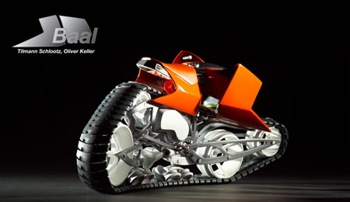
Here’s some creative thinking for motorcycling off road, it’s a tracked motorcycle. Ready to do battle with sand, snow or anything else, the Hyanide and Baal design concepts are part of the Michelin Challenge Design 2006 that’s taking place at the North American International Auto Show in Detroit.
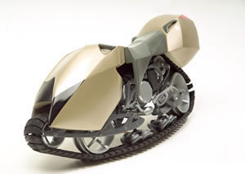Both the Hyanide and Baal designs are based on a bendable rubber track. The vehicles are steered by both hands and feet. The concepts are capable of many different engine variations, these were designed to accept a 500cc ATV engine, the type which are already mass produced. The Baal concept was thought to be the sort of vehicle that could be used in the Paris-Dakar or Baja races.
The German designers are Tilmann Schlootz and Oliver Keller. Nice work guys

