

800/7-7/40°/PAG/4ZR/28/8/82/A

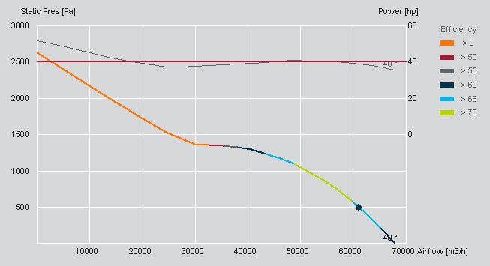

Impeller Information
Impeller Diameter | 800 mm |  | Speed | 2700 RPM
No of blades | 7 |  | Tip Clearance | 0,5 %
Pitch | 40 ° |  | Temperature | 15 °C
Blade Material | PAG |  | Elevation | 0 m
Blade Type | 4Z |  | Density | 1,225 kg/m3
Impeller Rotation | R
Tip Speed | 113 m/s |  | Moment of Inertia | 0,0855 kgm2
Air Velocity | 33,7 m/s |  | Blade Centrifugal force | 3670 N
Torque | 103 Nm |  | Axial Force | 603 N
Airflow | 61000 m3/h |  | Total Pres | 1200 Pa
Static Pres | 501 Pa |  | Power | 38,9 hp
Dynamic Pressure | 698 Pa |  | Efficiency | 70 %
Sound Power | Propagation: Not Free field |  | Sound Power 114 LW dB

Multi-Wing Ukraine | Patona 22/47 | +38 (032) 2400808 Telephone | taras@multi-wing.com.ua
Ukraine | - | +38 (032) 2400881 Fax | http://www.multi-wing.com.ua
 | 79040 Lviv

All technical data is given in accordance with Terms of sale and delivery for Multi-Wing Ukraine
We reserve the right to unnotified changes


Цена – 124 евро

С уважением,
Тарас Канафоцкий,
ООО "Мульти-Винг Украина"
тел/факс: +38032-240-08-08
+38032-240-08-81
cотовый: +38067-674-38-25
ICQ: 306-835-378
www.multi-wing.com.ua

