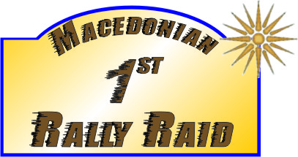 | 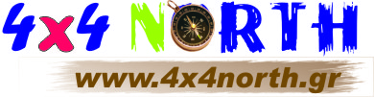

1st MAKEDONIAN RALLY RAID

REGISTRATION FORM

PILOT

Surname:_____________________________First Name:_________________________
Blood Group:____________________
ID No:__________________________
Driving license No:___________________issued on:____________________
racing license No:___________________
Address:____________________________
Tel:________________Fax:______________Μobile:______________
E-Mail :__________________Web Site:__________________________________

Vehicle Particulars

Make________________ Type _________________ chassis No:______________
Engine Displacement: _____cc plates no:________

Participation: I responsibly declare that I know special regulation of race and the provisions of N.S.P. In no case I will turn myself or I will make demand of organizers or of their representative or overseeing athletic community if either I, my drivers, my passengers and generally all my personnel from my registration or my attendance in this race suffer material, bodily or moral damage. I know that the sport in which I Wish to take part is DANGEROUS and accepts the concequences.

SIGNATURE Date .........................

Driver Organization

