

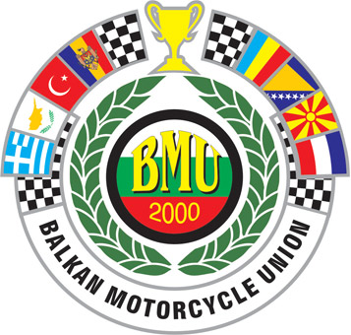
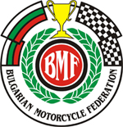


SUPPLEMENTARY REGULATIONS

EVENT
Name of the event: EASTERN EUROPE OPEN SM CHAMPIONSHIP
Classes: S1, S OPEN, SM JUNIOR 65/85, SM ATV (BMF NC)
Date: 7-8 November 2009
Organizing FMN: Bulgarian Motorcycle Federation (BMF)
Place of event: circuit “”, Haskovo, Bulgaria

ACCESS
Nearest airport Sofia , 180 km. from the circuit
Motorway: Plovdiv – Svilengrad
National Road:
Nearest City: Haskovo, 2 km. from the circuit

COURSE
Name: kart circuit “Haskovo”
Length of the track: 1300 m.
Type of surface: asphalt 70% and off-road 30%

ORGANIZER
Name: Bulgarian Motorcycle Federation

Address: Bulgaria, Sofia, 22 Pozitano Str.

Tel: + 359 886 411 400

Fax: + 359 2 980 5934
Email: gensek@bfm.bg

OFFICIALS
Jury President: BOGDAN NIKOLOV
Race Director: GEORGI PEEV
Clerk of the course: Pantaley Naydev
Chief Technical Steward: TBA
Chief timekeeping: Stoyan Grachenliev
FMNR Delegates: according to regulations
BMU Secretary: IVO TZVETANOV
Chief Medical Officer: Haskovo Municipality Hospital
Paddock Official:

FMN delegates according to the FIM and UEM Sporting codes.
The meeting will be held in accordance to the UEM Sporting code, the BMU Rules, the general rules of the FMNR and the present Supplementary Regulations, which has been duly examined and approved by the FMNR

ENTRIES
Entry forms, approved by the FMN of the participants must be sent to the organizer not later than the 6th November 2009

CLASSES

In accordance to the SM Article 2 of the BMU Regulations for 2009 the classes are:

SM Junior up to 85cc (65cc, 85cc and 150cc 4T) riders age – max. 15 years old)
SM S1 up to 450cc (4-strokes and 2-strokes)

SM OPEN from 451cc up to 1000cc

For the classes S1, and S OPEN there is no maximum age limit.
For the classes SM Junior 65/85 there will be separate classification.

TECHNICAL CONTROL AND VERIFICATION
According to the timetable attached.

JURY MEETINGS
According to the timetable attached.

PRACTICES
According to the timetable attached.

SCHEDULE OF RACES
According to the timetable attached.

FUEL
In accordance to the UEM specifications. The fuel can be obtained from the petrol stations in Haskovo, 2 km. from the track.

INSURANCE

By signing and stamping the entry form, the FMN of the rider certifies that the rider in insured in accordance to the UEM or FIM requirements.
The organizer disclaims all responsibility for damages of a motorcycle, its accessories and components arising from an accident, fire or other cases.

PRICE GIVING CEREMONY
Price giving ceremony will take place at the circuit in accordance with the timetable.

INTERPRETATION OF THE SUPPLEMENTARY REGULATION
The interpretation of these Regulations rests entirely with the International Jury

Additional race – Bulgarian Supermoto Championship class SM ATV.

Place: Sofia, Bulgaria

Date: 02.10.2009

Clerk of the course:

Approved by: (FMNR)

Sent to BMU: 02.10.2009

Approved by BMU:

