Win EasDiag Copyright (C) 2008. Created from Linux EASunlock source code. This program comes with ABSOLUTELY NO WARRANTY. This is free software and you are welcome to redistribute it under certain conditions under the terms of the GNU General Public License as published by the Free Software Foundation. By continuing you agree to the above terms.
History
The Range Rover (RR) Electronic Air Suspension (EAS) is an extremely unique and surprisingly robust system. The sequence of events that must take place to put the EAS into hard fault mode is more extensive than most people realize. Unfortunately once the EAS enters a hard fault condition there was nothing that any of us could do to reverse the situation. Now we finally have a reliable and portable method of resetting the EAS fault.

This small software package is a tremendous benefit to the RR P38 and Classic family of vehicles. The EAS system has simultaneously made the RR both a unique and vulnerable driving experience. The failure of the EAS has left thousands of people stranded or forced to drive in a potentially dangerous situation. It is our hope that this software will encourage people to be more adventurous with their very capable off-road vehicle. Hopefully this software will increase interest in the RR vehicle by removing the possibility of being stranded or stuck with an expensive system failure.

Anyone who has triggered an EAS fault knows how frustrating and dangerous the condition can be. Previously the only way to reset the EAS fault was to take the vehicle to either a dealership or a third party who owned a diagnostic toolset. Both afore mentioned methods would typically require driving the crippled vehicle on public roads and then paying a hefty fee to have the vehicle unlocked. The primary intention of this software is to prevent the Range Rover from forcing us to drive on a broken suspension.

It is important that although this software does read the diagnostic trouble codes that are stored in the EAS memory it is still necessary to diagnose the actual source of the faults. We encourage you to always fully diagnose your EAS faults. If faults are left unresolved a dangerous driving condition could present itself or additional EAS system components could be damaged further.

The EAS software has very few requirements. The primary requirement is a custom made OBDII serial cable for the P38a or a custom Diagnostics cable for the Classic. The P38a cable can be made with a soldering iron and two special ordered items. The necessary links and part numbers are listed below. Most standard OBDII serial cables will not work. Typically manufactures of OBDII cables will not include the pins that are necessary to communicate with the EAS serial communications interface. For our application, we need OBDII Male pins (12,11,5,1).
For the Classic you will require the Classic EAS diagnostic plug instead of the ODBII connector and a couple of electronic parts which can be easily purchased at an electronics store.

Links

OBDII Cable http://www.obd2cables.com/products/
Classic diag http://www.autosparks.co.uk/product_info.php?products_id=1776
DB9 Serial http://www.mouser.com

Part Numbers and Files

OBDII Pass-Through Cable Open J1962M/F 145701
Classic diagnostics connector C 875 - 5 Way TTS Plug Assembly
AIM D-Sub Connector 9 Pos Solder Female 601-40-9709S
AIM D-Sub Hood 601-40-9709HX

General information about connections

Connecting your PPC requires a different cable than you would use to connect to your PC or Laptop. If you wish to connect using both the PPC device and a PC you will either need to make two separate cables or make a second extension cable (NULL Modem) that switches the TX/RX and RTS/CTS around. I suggest that you first decide which device you will use most often to connect with and create the cable for that specific use. You can always then subsequently make/purchase a NULL Modem cable for the other. If you use some “standard” NULL Modem cable watch out because they don’t really exist. Some NULL Modem cables will only cross 2 and 3 and simply loop back all the control signals including RTS.

For connecting to your PPC device there are two possibilities. The simplest is to create a cable with a serial connector. Most PPC’s are sold with a serial/USB cable. The serial connector on this cable is generally a female. Alternatively you could create a single cable directly from the PPC to the ODBII/Diagnostics connector. I will not attempt to describe this as there are many different PPC’s all with their own specific connectors.

Connecting to the P38a ODBII connector

The diagram bellow shows a P38a cable for connecting directly to a PC or Laptop. In order to connect directly to a PPC make the following changes:
First you will need to use a DB9M (Male) connector instead of the DB9F (Female).
Connect pin 12 ODB to pin 2 DB9M
Connect pin 11 ODB to pin 3 DB9M
Connect pin 1 ODB to pin 8 DB9M
Connect pin 5 ODB to pin 5 DB9M

The alternative is to create the cable in the diagram and then create an addition extension cable with 2 DB9M connectors (the NULL Modem). Make the following connections.
Connect pin 2 DB9M to pin 3 DB9M
Connect pin 3 DB9M to pin 2 DB9M
Connect pin 7 DB9M to pin 8 DB9M
Connect pin 8 DB9M to pin 7 DB9M
Connect pin 5 DB9M to pin 5 DB9M

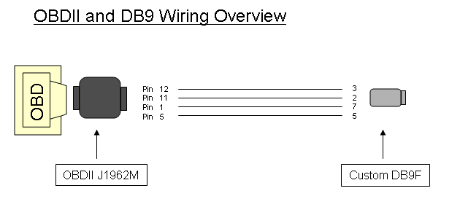

Connecting to the Classic EAS Diagnostics connector

For the Classic it is not sufficient to simply make connections. I will provide some explanation here. In order for the software to communicate with the EAS ECU it needs a way of switching the ECU off and on, the program does this by making the RTS signal from the RS232 port high to switch it on and low to switch it off. To do this we need to use an electronic switch called a transistor. The RTS acts as the signal for the transistor to either switch on or off thus making or breaking the power supply circuit to the ECU.

The same general discussion about NULL Modems is also valid for the Classic cable. Decide whether you will generally be connecting using a PC/Laptop or you PPC device. You can always use the NULL Modem cable to connect to the other device.

The diagnostic plug uses 4 pins. Send and receive for serial communication and the other 2 pins are used to complete the circuit i.e. when connected the ECU is on when disconnected off. If you have the Rave manuals it is C365.
Connect pin 2 from the serial port to pin 4 of the diagnostics plug.
Connect pin 3 from the serial port to pin 1 of the diagnostics plug.
Connect pin 5 from the serial port to pin 5 of the diagnostics plug.
Now you need to purchase a transistor and a resistor (total cost less than 1 euro). The transistor is a BC108 (or equivalent) and the resistor is a 15K4 or the closest you get to that value. They should know what you are talking about in the shop. The BC108 is packaged in a TO18 case. If you look up BC108 and TO18 on the web you will find the pin out, this will tell you which pin is the base, emitter and collector. You can also ask in the shop.
Connect the RTS, pin 7 on the serial port to the 15K4 resistor (it doesn't matter which way round). Connect the other end of the resistor to the "base" of the BC108. Connect the "collector" of the BC108 to pin 5 of the diag connector. Connect the "emitter" of the BC108 to pin 3 of the diag connector.

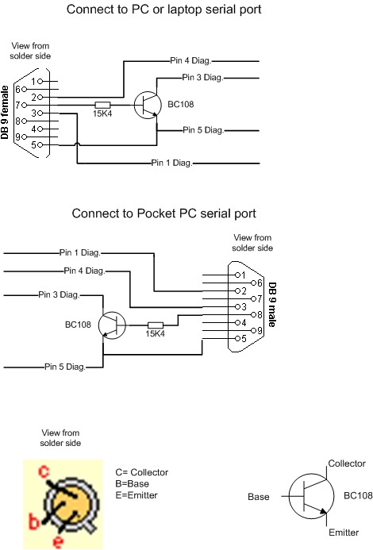

Cables for the P38a can be ordered premade from http://www.argusvisual.com/cables
Cables for the Classic can be ordered by contacting r.garrod@xs4all.nl
The cables provided by argusvisual for the P38a are designed for use with a PC/Laptop. In order to use these cables with EasDiag you will need an additional NULL modem cable described in the document.
The cables themselves are not expensive but the shipping can be twice the cost of the cable. If you can use a soldering iron or know someone who can both these cables can be easily made.

Trouble Shooting and Best Practices:
As always make sure your EAS cable has been made properly before attempting to work with this application. Do not waste your time on troubleshooting operations when your cable is suspect. I can not stress enough to get a good working reliable cable. I do not want to see people sticking loose stripped wires into serial connectors. People please save yourself the trouble and proceed with a well made cable setup. It is worth the investment as you will most likely be using the EAS applications in the future.
Switch the car ignition into the Second position. The car stereo and HEVAC
should now be on. Plug in the EAS serial communications cable to both the
OBDII/Diagnostics plug and the Serial port. Start the EasDiag application. Choose “Faults” from the EAS menu and click on “Check Connection”. If all is well you will get a message that the EAS is awake. If you do not get this message you have a cable problem. Do not go any further but first sort out this problem. If you do get the message that the EAS is awake then try the “Read Faults” button. If you get a long list of errors including “DUMMY” the program is not synchronizing correctly. First try the whole procedure again by switching off the vehicle and then back on to the second ignition position. Then Shutdown and restart the EasDiag application.
If then Read Faults function continues to show DUMMY faults then either the EAS is not powered up or the cable has been made incorrectly. On the Classic you should hear a couple of clicks (one second apart) from a relay under the right hand seat when you try the read faults command. The EAS fault light should light for one second and then go out again.

General:

The zip file distribution contain 3 files. This document the setup program and a cab file. Simply run the Setup program. This will install EasDiag on the Pocket PC device the next time you connect it to your PC. The cab file is provided purely for convenience in case the setup does not work with your PPC device. Copy the cab file to the PPC device and click on it.

EasDiag was developed using eVC4 (embedded Visual C++ Version 4) which generates a single executable which requires no additional files or frameworks to be installed on the PPC device.

The Read Faults routine will probably show a “Vehicle has moved” fault, this is not a real fault (I would be more worried if the vehicle didn’t move). You can easily clear it as a test.

Updates:

Beta 2
Has been renamed EasDiag.
Is now installed with a standard setup program from the PC. This will install the program in the correct fashion on the Pocket PC device. The program will be installed in the Program Files folder on the PPC device.
Clear faults has been enhanced adding a powercycle after the reset which should extinguish all warning and error lights once the reset is completed.
Added pump on/off and profile height choice in the Calibrate screen.
Added some extra error messages to the Read Faults routine.

Beta 1
This is the initial Beta version. It has been tested on a ’95 model Classic.

