LUCAS 10AS ALARM - Pin Outs
Details of the pin usage for the ECU connector(s).
Grey Connector | 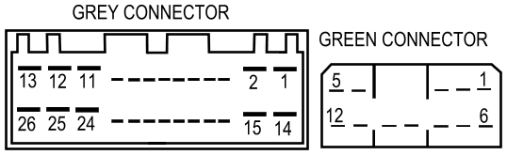
1 | Interior lights – inputs
2 | Not used
3 | Volumetric signal - input
4 | DDS serial link - output
5 | Drivers door – input
6 | Passengers still - input
7 | Drivers still – input
8 | Door key switch - input
9 | Bonnet
10 | Ignition – input
11 | Malfunction indicator lamp - input
12 | Ground – input
13 | Not used
14 | Active low immobiliser - output
15 | Active high immobiliser - output
16 | Passenger's doors / tailgate - input
17 | Serial comms
18 | Not used
19 | Not used
20 | Volumetric power - output
21 - 23 | Not used
24 | Serial ground – input
25 | Battery voltage – input
26 | Aerial – input

Green Connector
1 | Hazard right - output
2 | CDL lock - output
3 | CDL unlock - output
4 | Security LED - output
5 | Sounder drive - output
6 | Hazards left - output
7 | Transponder drive - output
8 | Hazard power input
9 | EIWL - output
10 | Crank output
11 | Ground - input
12 | Transponder power - output

