2004-09 Kawasaki KFX700 M-7 V.A.L.E.™ Stainless Steel Full Race System:
With the patented use of magnesium, aluminum and stainless steel, and hours of testing, we have developed an exhaust system that performs for all levels. Whether you are on the racetrack, trail riding, woods riding or just having fun in the sand this exhaust performs. Performance gains are seen and felt in every part of the powerband. We are sure that when you pull this exhaust system out of the box, install it on your ATV, and feel the performance you will agree that it is The Absolute Top Level™.
The Two Brothers M-7 off-road stainless/aluminum exhaust systems come complete with a U.S. Forestry Service approved removable screen type spark arrestor.
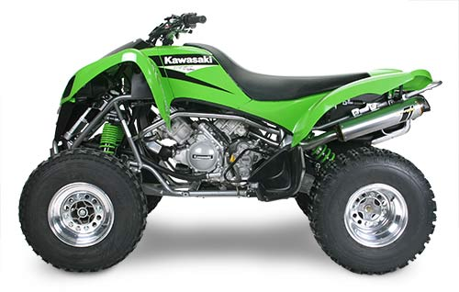
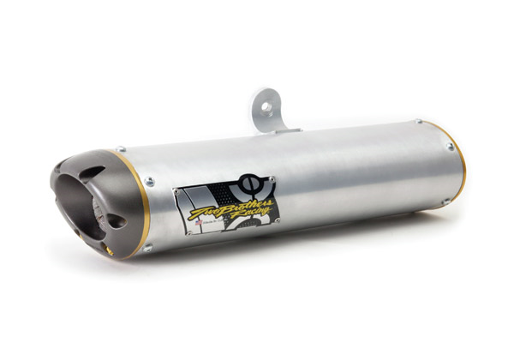
Description:
With the patented use of magnesium, aluminum and stainless steel, and hours of testing, we have developed an exhaust system that performs for all levels. Whether you are on the racetrack, trail riding, woods riding or just having fun in the sand this exhaust performs. Performance gains are seen and felt in the critical areas of the powerband.
The Two Bros M-7 off-road exhaust systems come complete with a U.S. Forestry Service approved removable screen-type spark arrestor.
KFX700 M-7 Full System
Now that’s a beefy ATV! With 700cc’s of twin cylinder power to work with, Two Brothers Racing’s ATV crew called in the sport bike specialists to develop a truly sweet setup. Incredibly lightweight and flow-matched to produce optimum power (not just more of it), our KFX700 two-into-one system has the attitude and performance a bike like this demands.
-5.2 lbs +1.3 HP
