Модел
2000г
Jeep Grand Cherokee Limited WJ
Двигател - 3.1td
Раздатка - Quadra Trac II (NV247)
Скоростна кутия - 4 Speed Automatic (42RE)

Подръжка. Части. Течност. Интервали.

Охладителна Система ---? 100 000км (5 години)
Течност - Антифриз/вода - 50/50
Количество - 12л (+ 1.9л за допълващата ботилка)

Масло двигател --- 10 000км (6 месеца)
Количество - 7.2л

Горивен филтър --- 10 000км (6 месеца)
P/N 05003594AA

Въздушен филтър --- 40 000км (2 години)

Скоростна кутия. Автоматична 4 степенна (42RE) --- 50 000км
Течност - Mopar® ATF +4, type 9602
Филтър - (internal, flat) Primary: P/N 52118789
Количество - Service Fill 3.8L / O-haul Fill 9.1-9.5L

Раздатка (Transfer case). Quadra Trac II (NV247) --- 40 000км
Течност - Mopart Transfer Case Lubricant P/N 05016796AB
Количество - 1.6л

Преден диференциял (Dana 30 (186FBI)) --- 20 000км
Течност - Mopar® P/N 04874469 (SAE 75W-140 SYNTHETIC Gear Lubricant. Качество - MIL-L-2105C и API GL 5.)
Количество - 1.18л

Заден диференциал (Dana 35C) --- 20 000км
Течност - Mopar® P/N 04874468 (SAE 80W-90 Gear Lubricant. Качество - MIL-L-2105C и API GL 5.)
При големи натварвания - Mopar® P/N 04874469 (SAE 75W-140 SYNTHETIC Gear Lubricant. Качество - MIL-L-2105C и API GL 5.)
Количество - 1.66л

Смазване на връките на окачването (suspension ball joints) --- 20 000км
Течност - Mopar® NLGI Grade 2 EP, GC-LB.

Спирачна течност --- 100 000км (2 години)
Течност - Mopar® Brake/clutch fluid FMVSS No. 116, DOT-3 & SAE J1703.

Спирачни дискове? --- 30 000км (18 месеца)
P/N 52098672 Rotor
P/N 5093174AB Caliper kit (2 calipers, pads and retaining bolts)

Спирачки. Смазване и почистване --- 30 000км (1 година)

Въздушен филтър на кабината --- (2 години)
Mopar® P/N 5013595AA

Серво система --- 10 000км(само проверка)
Течност - Mopar®P/N 04883077 Hydraulic fluid / Power steering fluid (MS5931)

Климатик --- ?
Течност - R-134A
Количество - 0.69кг

Свещи --- ?30 000км (за бенизиновите)

Ремък --- 100 000км
P/N 05015962AA

Смяна местата на гумите --- 10 000км
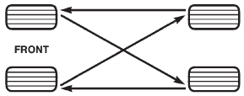

Гуми - нялягaне
227kPa ; 33psi

Подръжка. Интервали.

При всяко зареждане на гориво
Проверка и допълване:
- маслото двигател
- течност чистачки

Всеки месец
- проверка налягане на гумите
- оглеждане на гумите за наранявания
- проверка на акумулатора, почистване и затягане на връзките
Проверка и допълване:
- охлаждаща течност
- течност серво управлението
- течност скоростна купия

При всяк смяна на маслото (10000км, 7,500мили)
- преглед на изпускателната система
- преглед на спирачните маркучи
- смяна местата на гумите
- проверка и допълване охлаждаща течност, проверка на маркучи и скоби
- смазване на връките на окачването (suspension ball joints)

Други неща за смазване
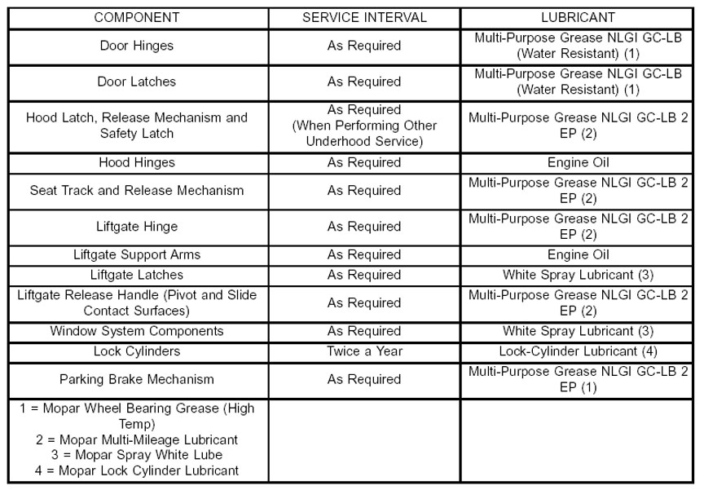

Диагностика. Кодове.
Изкарване на грешките -
Завъртете ключа на On докато се появи цифровия килопетраж. След това 3 пъти превключете On/Off, On/Off, On/Off, On.
На четвъртото On километражът ще изпише грешките, ако няма грешки ще изпише Done.
Кодове: http://www.wjjeeps.com/faultcodes.htm#0010

Кое Къде Как?

Смазване на връките на окачването (suspension ball joints)
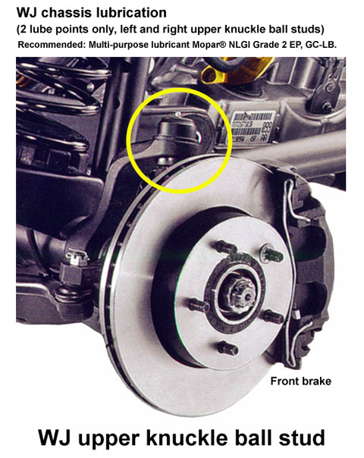

Скоростна кутия - проверка на маслото
1. При загрят двигател, о/у 82°C
2. Спрете на равно място
3. Дръпнете ръчната спирачка
4. Превкллучете скоростната кутия на всички предавки и след това я оставете на неутрална(N)
5. Почистете капачката на пробната пръчка и самата пробна пръчка
6. След това се извършва пробата и при нужда се добавя ATF+4

Скоростна кутия - обслужване
REMOVING PAN AND FILTER(S)
1. Hoist and support vehicle on safety stands.
2. Place a large diameter shallow drain pan beneath the transmission pan.
3. Remove bolts holding front and sides of pan to transmission.
4. Loosen bolts holding rear of pan to transmission.
5. Slowly separate front of pan away from transmission allowing the fluid to drain into drain pan. A flat plastic trim tool can be used or carefully tap on edges with rubber hammer.
6. Hold up pan and remove remaining bolts holding pan to transmission.
7. While holding pan level, lower pan away from transmission.
8. Pour remaining fluid in pan into drain pan.
9. Remove single screw holding filter to valve body.
10. Separate filter from valve body and oil pump and pour fluid in filter into drain pan.
11. Remove and discard the oil filter seal from the bottom of the oil pump.
12. If replacing the cooler return filter (suggested), use oil filter wrench (Mopar #8321) to remove the filter from the transmission. (NOTE: 45RFE or 545RFE transmission only)
13. Dispose of used trans fluid and filter(s) properly.
14. Inspect bottom of pan and magnet for excessive amounts of metal. A light coating of clutch material on the bottom of the pan does not indicate a problem unless accompanied by a slipping condition or shift lag.
15. Using a suitable solvent, clean pan and magnet.
16. Using a suitable gasket scraper, thoroughly clean original sealing material from surface of transmission case and the transmission pan. NOTE: for 42RE transmission the transmission pan oil gasket may be reusable. Inspect the sealing surfaces of the gasket. If the sealing ribs on both surfaces appear to be in good condition, clean the gasket of any foreign material before reinstalling.
17. Let remaining fluid drain, the longer the better if you want to get more of the old fluid out.
FILTER AND PAN INSTALLATION
1. Install a new primary oil filter seal in the oil pump inlet bore. Seat the seal in the bore with the butt end of a hammer, or other suitable tool.
CAUTION: The primary oil filter seal MUST be fully installed flush against the oil pump body. DO NOT install the seal onto the filter neck and attempt to install the filter and seal as an assembly. Damage to the transmission will result.
2. Place replacement filter in position on valve body and into the oil pump.
3. Install screw to hold filter to valve body. Tighten screw to 40 in. lbs. (4.5 N·m) torque.
4. If changing cooler return filter, install new one onto the transmission. Torque the filter to 125 in.lbs. (14.12 N·m) (NOTE: cooler filter is only used on the 45RFE and 545RFE transmissions).
5. Place 1/4" or so bead of Mopar RTV sealant onto the transmission case sealing surface (45RFE and 545RFE). For 42RE transmission reinstall gasket or install new gasket.
6. Place pan in position on transmission.
7. Install bolts to hold pan to transmission. Carefully tighten bolts to 105 in. lbs. (11.8 N·m) torque. Allow RTV sealant to set for 15-30 minutes (45RFE and 545RFE).
8. Lower vehicle and fill transmission with Mopar ATF +4, as described in the Fluid Fill steps below.
TRANSMISSION FLUID FILL
To avoid overfilling transmission after a fluid change or overhaul, perform the following procedure:
1. Remove dipstick and insert clean funnel in transmission fill tube.
2. Add following initial quantity of Mopart ATF +4 to transmission:
(a) If only fluid and filter were changed, start by adding 10 pints (5 quarts) of ATF +4 to transmission.
(b) If transmission was completely overhauled and the torque converter was replaced or drained, start by adding 24 pints (12 quarts) of ATF +4 to transmission.
3. Check the transmission fluid level and adjust as required by following the CHECKING THE TRANSMISSION FLUID LEVEL directions above.

