2006 KAWASAKI Brute Force 750 4x4i

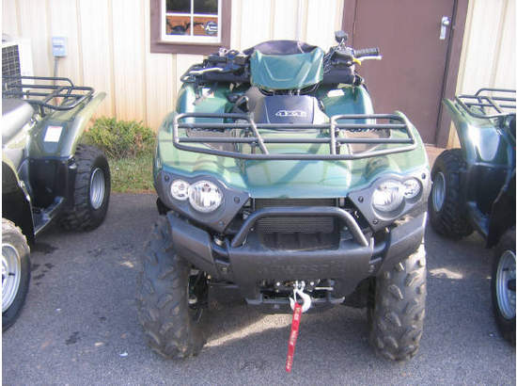

VEHICLE DETAILS
- Year:2006
- Make:KAWASAKI
- Model:Brute Force 750 4x4i
- Location:La Grange, GA
- Type:All Terrain Vehicle
- Mileage:0

SELLER DESCRIPTION
2006 KAWASAKI Brute Force 750 4x4i , The Brute Force 750 4x4i, the ultimate 4x4 all-terrain vehicle (ATV) powered by Kawasakis awe-inspiring V-twin engine, has returned for 2006 and its sporting an all-new color. In addition to popular Aztec Red and Woodsman Green, and two camouflage patterns, the Brute Force 750 4x4i is now available in all-new Galaxy Silver, further highlighting the aggressive angular lines of this Kawasaki flagship. Simply put, the Brute Force 750 4x4i is the most powerful, high-performance model in its class, offering a superior balance of rider comfort and convenience features. Built with adventure enthusiasts and sportsmen in mind, its cloaked in aggressive bodywork and powered by the largest V-twin engine on market, and it utilizes a fully independent rear suspension (IRS) system. The Brute Force 750 4x4i is powered by Kawasakis revolutionary 90-degree, four-stroke V-twin engine. Displacing 749cc, it features Electrofusion-plated aluminum cylinders, a reverse-facing air intake, 34mm downdraft carburetors, straight intake tracts, and four valves per cylinder. It also features a high-efficiency radiator mounted high in the chassis where it is best protected from mud and debris. To assist with braking, the engine features the Kawasaki Engine Brake Control, which helps to slow the ATV when traversing steep downhills.

