12W 1800 Lm Zoomable CREE XM-L T6 LED 18650 Rechargeable Flashlight Torch Lamp+2X 18650Battery+2Xcharger

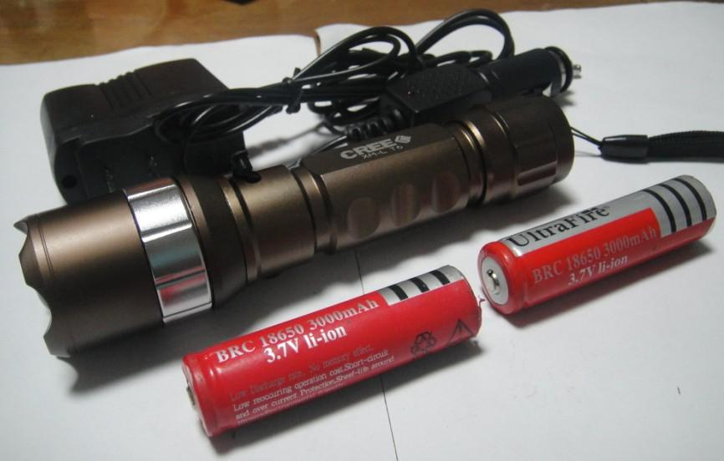

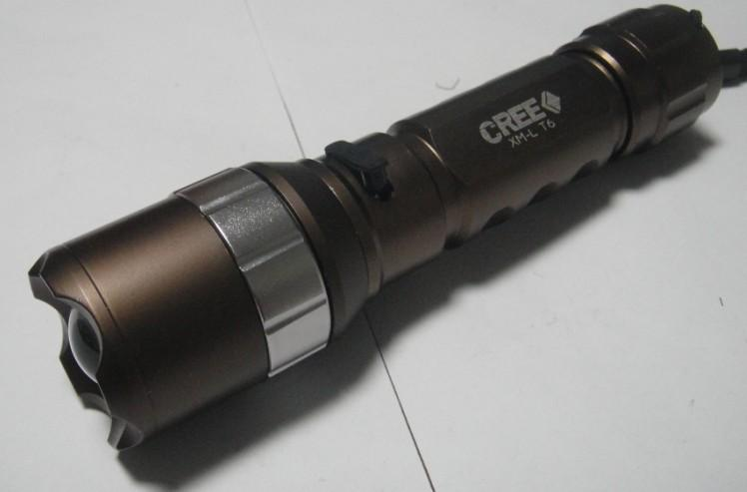

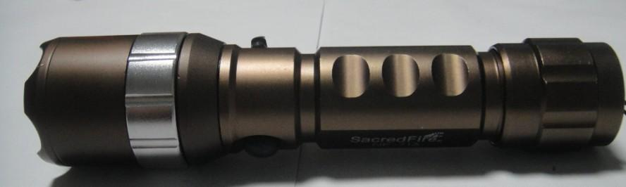

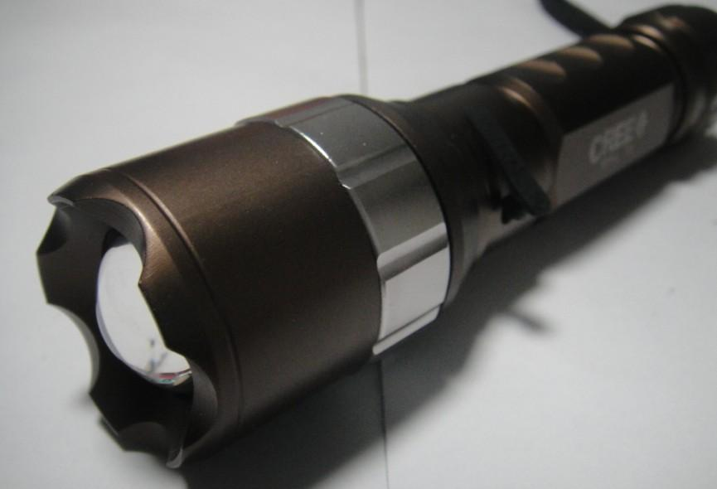
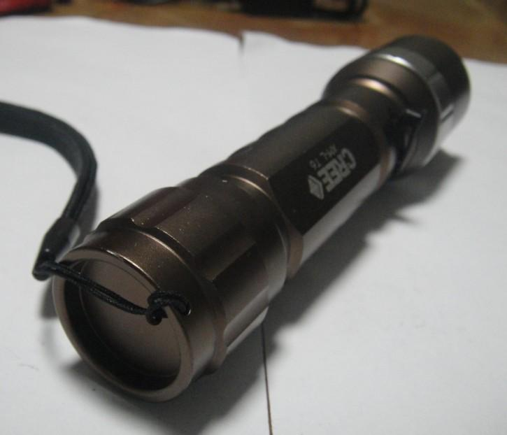
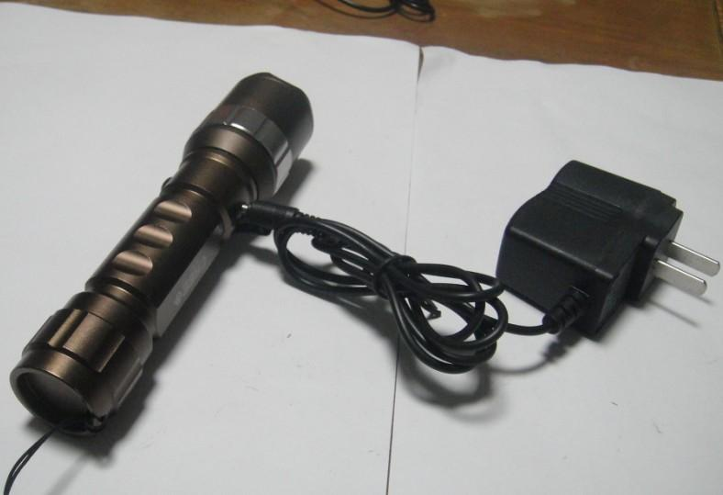

Product Introduction:
- 100% Brand New CREE XM-L T6 LED Adjustable Focus Torch
- Made of high quality 6061T aluminum alloy, this flashlight is sturdy and durable enough for long time daily using
- Lamp base: CREE, high power LED. With a lifespan of up to 100,000 hours or more, no need to consider replacing the cap for the whole life.
- Waterproof, but don't put it into water long time
- Super Bright, blinding Effect
- Crenellated strike bezel for enhanced self-defense
- 5 Mode: high / low / strobe / Zoom In & Zoom Out
- Bulb: CREE XM-L T6 LED
- Switch Location: Tailcap (middle)
- Max output: 1800 lumens
- Power by: 1x 18650 3.6v/3.7v
- Size(mm):148 x 33(bezel)/28(body)
- Net Weight (g): 150g

Package
- 100% Brand New
- 1 x CREE LED XM-L Zoomable Flashlight Torch
- 1 X Charger (110v-240v) for this flashlight
- 1 X Car charger
- 2 x 18650 3.7v 3000mAh Rechargeable Battery
- 1 x Plug Adaptor to suit your Country

